**PRACTICAL: 10**

*Test of Significance based on f-distribution.*

**FORMULA USED:**

1. **F STATISTIC:**
$$F=\frac{U/{ν_{1}}}{V/{ν_{2}}}$$

$$U and V are independent chi-squared variable.$$

$$ν_{1} and ν_{2 }are degrees of freedom respectively.$$

2. **HYPOTHESIS STEPS :**

$$1. Define Null Hypothesis, H_{0}:θ$$

The Null Hypothesis for f-distribution is:

$$H_{0}:σ_{1}^{2}=σ_{2}^{2} | σ_{1}=σ_{2}$$

$$2. Define Alternative Hypothesis, H_{1}:θ<θ_{0 }\left| θ>θ_{0 }\right| θ≠θ_{0 }$$

$$3. Define Level of Significance, α(Mostly 0.05 or 0.01)$$

$$4. Define Critical Region on the basis of step 2 and 3 \left(One tailed or two tailed\right).$$

$$5.Perform calculations using the given data to calculate Test Statistic.$$

$$6. Conclude by comparing the statistic with H_{1}$$

$$7. Perform p-Value Test for strong evidence.$$

**Question:** To find out whether a new serum will arrest leukemia, 20 mice with an advance stage of the disease are selected.10 mice receive the treatment and 10 did not. Survival Times from the experiment commenced are as:

|  |  |
| --- | --- |
| TEN MICE WITH TREATMENT | TEN MICE WITHOUT TREATMENT |
| 2.1 | 1.9 |
| 5.3 | 0.5 |
| 4.1 | 2.8 |
| 1.4 | 3.1 |
| 4.6 | 4.5 |
| 0.9 | 2.3 |
| 6.4 | 1.3 |
| 2.3 | 3.4 |
| 5.6 | 3.6 |
| 5.5 | 0.6 |

At 0.05, level of significance, can the serum be said to be effective. Assume the two populations to be normally distributed with equal variances.

**Answer:** Using Hypothesis Testing, We know that when the population variances are to be compared upon their variances, we can apply F test.

$H_{0}: σ_{1}^{2}=σ_{2}^{2}$

$H_{1}:σ_{1}^{2}-σ_{2}^{2}>0$

$α=0.05$

1. As indicated by the alternative hypothesis, it is a one tailed problem, in fact a right tailed problem.

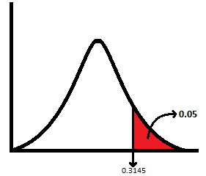

Hence, Critical Region is given as:

**F>0.3145**

1. Using Data Analysis Tool:

|  |  |  |
| --- | --- | --- |
|  | *WITHOUT TREATMENT* | *WITH TREATMENT* |
| Mean | 2.4 | 3.82 |
| Variance | 1.757777778 | 3.908444444 |
| Observations | 10 | 10 |
| df | 9 | 9 |
| F | 0.449738458 |  |
| P(F<=f) one-tail | 0.124800073 |  |
| F Critical one-tail | 0.314574906 |  |

1. Using the above table we can see that P (F<=f) is 0.125 (p value).

Since

$$p>α$$

We can strongly say that we reject the Null Hypothesis in favor of Alternative Hypothesis.

**Question 2:** To find out whether Male and Females dedicate on an average equal time to study hours. 30 Males and 30 Females are observed and their study hours are recorded. Recorded Study Hours are as follows:

|  |  |
| --- | --- |
| MALE | FEMALE |
| 2 | 4.50 |
| 6 | 5.00 |
| 3.4 | 2.20 |
| 3 | 6.50 |
| 5 | 6.80 |
| 1 | 5.40 |
| 4 | 3.00 |
| 7 | 8.00 |
| 4.5 | 2.00 |
| 4 | 5.00 |
| 9 | 1.00 |
| 4.5 | 0.10 |
| 5 | 0.90 |
| 2.1 | 1.70 |
| 0.9 | 1.20 |
| 3 | 6.00 |
| 5 | 7.00 |
| 1.2 | 2.30 |
| 4 | 3.40 |
| 3.2 | 7.80 |
| 8.3 | 5.30 |
| 7 | 3.30 |
| 3 | 2.40 |
| 5 | 1.20 |
| 7.6 | 2.30 |
| 3.4 | 6.70 |
| 2.3 | 9.80 |
| 9.4 | 3.00 |
| 2 | 2.00 |
| 1 | 5.00 |

**Answer:** Using Hypothesis Testing, We know that when the population variances are to be compared upon their variances, we can apply F test.

$H_{0}: σ_{1}^{2}=σ_{2}^{2}$

$H_{1}:σ_{1}^{2}-σ_{2}^{2}≠0$

$α=0.05$

1. As indicated by the alternative hypothesis, it is two tailed problem.

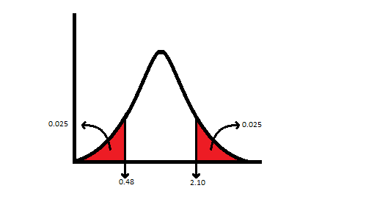

Hence the Critical Region is:

**F < 0.48**

**F > 2.10**

1. Using Data Analysis Tool:

|  |  |  |
| --- | --- | --- |
|  | *Variable 1* | *Variable 2* |
| Mean | 4.226666667 | 4.026666667 |
| Variance | 5.685471264 | 6.295126437 |
| Observations | 30 | 30 |
| df | 29 | 29 |
| F | 0.90315442 |  |
| P(F<=f) one-tail | 0.392865179 |  |
| F Critical one-tail | 0.537399965 |  |

1. Using the above table we can see F lies in the Confidence Interval

We can strongly say that we fail to reject the Null Hypothesis.

**INFERENCE:**

1. In the first Question, we rejected the Null Hypothesis in favor of Alternative Hypothesis; hence we can infer that the new serum is effective in arresting the leukemia disease.
2. In the Second Question we fail to reject the Null Hypothesis; hence we can infer that Males and Females spend equal hours in study.